**Northeastern Illinois University**

## 22/07/2014

**Build Instructions**

**Timesheet & Leave Management System**

***Team Members* :**

#### Lakshmi Vasundhara Thammishetty

#### Anusha Bestha

#### Jyoti Behera

#### Sumanth Tadikonda

#### Sushma Adepu

DOCUMENT RELEASE NOTICE

**Document Details:**

|  |  |
| --- | --- |
| **Name** | **Description** |
| Build Instructions for Timesheet and Leave Management System. | This document for **Timesheet & Leave Management System** Of **Northeastern Illinois University** includes instructions for building the project along with download and installations instructions to softwares used to develop the project. |

*Table of Contents*

*1 -* *Environemnt Setup* *4*

*1.1– Eclipse IDE 4*

*1.2– JRE1.6 & JDK1.6 4*

*1.3 – Apache Tomcat Server 4*

*1.4 – MySql 5*

*1.5 – Configuring Tomcat server for Eclipse 5*

*2 -* *Project Setup 6*

*2.**1 – Download 6*

*2.**2 – Eclipse 6*

*2.3 – MySQL 8*

*2.4 – Login 9*

1. ***Environment Setup***

1.1  **Eclipse IDE for Jave EE Developers**

* Download the software from the following link with your computer specifications. Availabale for Windows , Mac OX and Linux.

<https://www.eclipse.org/downloads/>

* Installation instructions are available at <http://wiki.eclipse.org/Eclipse/Installation>
  1. **JRE1.6 & JDK1.7**
* Download the JRE and JDK versions from the following links and install.

[http://www.oracle.com/technetwork/java/javasebusiness/downloads/java-archive- downloads-javase6-419409.html](http://www.oracle.com/technetwork/java/javasebusiness/downloads/java-archive-%20%20%20%20%20%20%20%20%20%20%20%20%20downloads-javase6-419409.html)

* Default installation path C: -> ProgramFiles -> Java
* Go to MyCompter -> Properties -> Advanced System settings ->Advanced -> Environment Variables.
* Go to systemVariables-> Find PATH variable and append the path C:\Program Files\Java\jdk1.7.0_15\bin to Path Variable value.
* Go to SystemVariables -> Find JAVA_HOME variable and append

C:\Program Files\Java\jdk1.7.0_15 to JAVA_HOME variable value.

* 1. **Apache Tomcat Server**
* Download the software from the following link.

<http://tomcat.apache.org/download-60.cgi>

Download and installation instructions.

* Download the apache tomcat server specific to your computer .
* Extract the zip folder and paste it in c drive of your computer and rename it to tomcat.
* Go to MyCompter -> Properties -> Advanced System settings ->Advanced -> Environment Variables.
* Go to path and append the path C:\tomcat\bin to PATH variable value.
* Create new variable in user variables with name classpath.
* Append C:\tomcat\lib
* Click OK .
* Go to C:\tomcat\bin and double click startup.bat (batch file)
* If everything is properly configured, tomcat server will start up.
* In the cmd prompt , in the end INFO : server startup will be displayed.
* Tomcat will be configured on port 8080. Go to browser and open localhost:8080
* Apache tomcat homepage will be displayed.

Reference : <http://www.youtube.com/watch?v=ag_i8e7Qliw>

* 1. **MySQL**
* Download MySQL software from following link.

<http://dev.mysql.com/downloads/mysql/>

Download and installation instructions

* Go to Community Server from the above link and download the MySQL installer package specific to your computer.
* Run the mysql-installer-community downloaded.
* Click on Install MySQL products.
* Accept -> Next -> Execute->Next
* Select Developer Default option for setup type.
* Next -> Next -> Execute ->Next -> Next
* Config Type : Development Machine , Port : 3306 ->Next
* Give Password : root , username will also be root. ->Next
* Select Standard System Account -> Next
* Finish.
* Workbench will open.
* Go to database -> query database
* Click store in Vault and set password given earlier i.e root.

Reference : <http://www.youtube.com/watch?v=iP1wOSsKjW8>

When setting up MySQL ,

Schema : test

username : root

password: root

* 1. **Configuring Tomcat server for Eclipse**
* Open eclipse.
* Window->Open perspective -> select Java EE.
* Go to window -> preferences.
* Go to server -> Runtime environment->Add
* Select Apache Tomcat v6.0 -> Next.
* Give path to Tomcat installation directory. C:\tomcat
* Finish.
* Go to server palet. If not available go to window->show view and add servers.
* Right click on server palet. New -> server -> Apache Tomcat 6.0 -> Next->Finish.
* Now the server will appear in the server palet.
* Right click on server -> start.

1. ***Project Setup***

**2.1 Download**

* Download the project files from the following link.

<https://github.com/sstadiko>

* Download archive folder Timesheet_Leave_Management
  1. **Eclipse**
* Right click on project explorer.
* Import the archive folder downloaded.

**Alternate**

* Open Eclipse and create a new Dynamic Web Project and name it as Timesheet_Leave_Management
* Unzip the archive file.
* Create a new package ‘timesheet’ in src folder of the project and copy the contents of src folder.
* Open web.xml file from WebContent -> WEB INF.
* Copy the contents of web.xml from the project folder to your project web.xml.
* Copy the contents of WebContent from the unzipped archive to your project’s WebContent folder.
* The structure will be like the picture attached below.

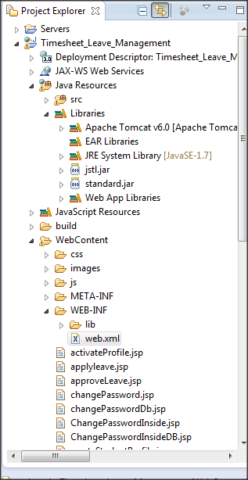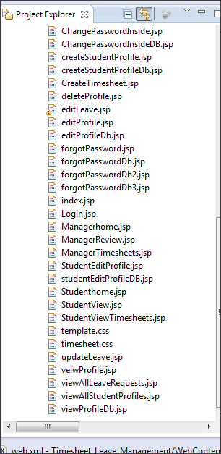

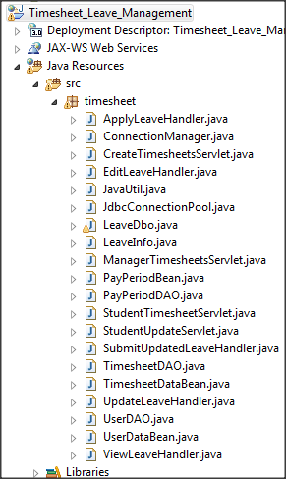

* Go to window->preferences->general->web browser and choose your default web browser. The default will be eclipse browser.
* Open eclipse . Right click on project -> Run As -> Run on server.
  1. **MySQL**
* Unzip the DatabaseDump folder provided in the project folder.
* Import the folder into MySQL workbench.
* Server->DataImport->Select the folder and import.

**ALTERNATE WAY**

* Copy the T&LDatabase.doc and execute in MySQL workbench.
  1. **Login**
* Now the login page will be opened in the browser.

Login with the credentials :

UserName: testmanager

Password: test123

Login to Student Page

Credentials

Username: testStudent

Password: test123